Debugging Summary

7 Aug 2019

# Step 1: Run 1 pub, 1 sub on single machine on all machines

Here is the script I used for all the tests in step 1:

start cmd /k perftest_java.bat -pub -dataLen 4096 -domain 2 -latencyCount 10000 -numIter 10000000 -bestEffort -multicast

start cmd /k perftest_java.bat -sub -dataLen 4096 -domain 2 -latencyCount 10000 -numIter 10000000 -bestEffort -multicast -fileName sub1

## Windows Machine 1 (nsq905ap):

Publisher Ended:

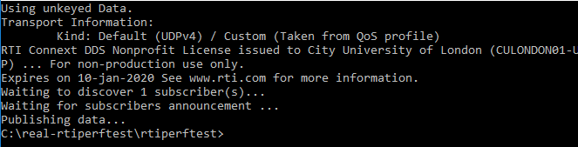

Subscriber Continued:

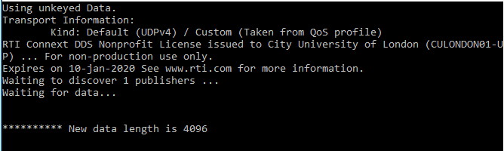

## Windows Machine 2 (nsq906ap):

Publisher Ended:

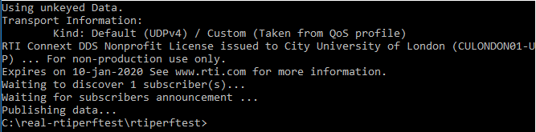

Subscriber Ended:

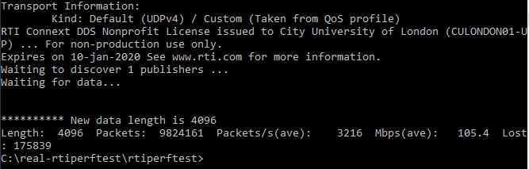

## Windows Machine 3 (nsq907ap):

Publisher Ended:

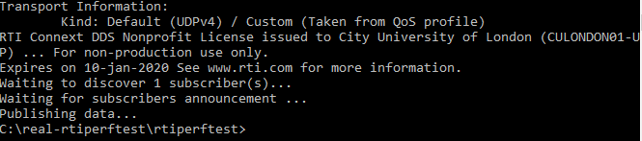

Subscriber Ended:

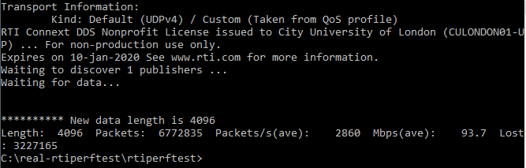

## Windows Machine 4 (nsq908ap):

Publisher Ended:

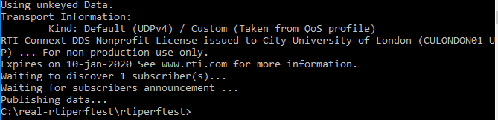

Subscriber Continued:

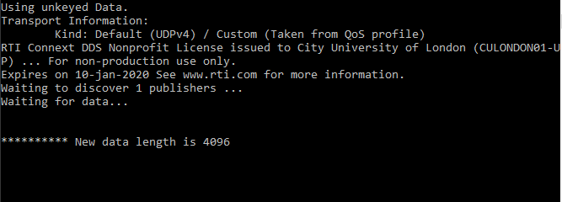

# Step 2: Run 1 pub, 1 sub on separate machines in different pairs/combinations

Here is the script for the subscriber used in all tests in step 2:

start cmd /k perftest_java.bat -sub -dataLen 4096 -domain 2 -latencyCount 10000 -numIter 10000000 -bestEffort -multicast -fileName sub1

Here is the script for the publisher used in all tests in step 2:

start cmd /k perftest_java.bat -sub -dataLen 4096 -domain 2 -latencyCount 10000 -numIter 10000000 -bestEffort -multicast -fileName sub1

## Combination 1: VM 1 + VM 2 (nsq905ap + nsq906ap):

## Combination 2: VM 1 + VM 3 (nsq905ap + nsq907ap):

## Combination 3: VM 1 + VM 4 (nsq905ap + nsq908ap):

## Combination 4: VM 2 + VM 3 (nsq906ap + nsq907ap):

## Combination 5: VM 2 + VM 4 (nsq906ap + nsq908ap):

## Combination 6: VM 3 + VM 4 (nsq907ap + nsq908ap):

# Step 3: Run step 1 simultaneously

In this step 1 pub, 1 sub would be run on one machine while another machine is also running the same type of test just with a different domain.

Here is the script I used for all the tests in step 3:

start cmd /k perftest_java.bat -pub -dataLen 4096 -domain 2 -latencyCount 10000 -numIter 10000000 -bestEffort -multicast

start cmd /k perftest_java.bat -sub -dataLen 4096 -domain 2 -latencyCount 10000 -numIter 10000000 -bestEffort -multicast -fileName sub1

## Combination 1: VM 1 + VM 2 (nsq905ap + nsq906ap):

## Combination 2: VM 1 + VM 3 (nsq905ap + nsq907ap):

## Combination 3: VM 1 + VM 4 (nsq905ap + nsq908ap):

## Combination 4: VM 2 + VM 3 (nsq906ap + nsq907ap):

## Combination 5: VM 2 + VM 4 (nsq906ap + nsq908ap):

## Combination 6: VM 3 + VM 4 (nsq907ap + nsq908ap):